**Evaluation of step response, frequency response and disturbance response of the nonlinear model of electromechanical engine gimbal control (EGC) system using MATLAB/SIMULINK**

**Abstract:**

We want to:

1. To understand the effect of nonlinear elements like coulomb friction and speed torque limits of motor on the step response and frequency response of electromechanical EGC system.
2. Disturbance response of closed loop EGC system for different values of integral controller gains.

**Literature Survey:**

The nonlinear SIMULINK block diagram representation of electromechanical engine gimbal control system using PI plus rate feedback controller is shown in Fig.1. The details of various nonlinear elements are given below:

### Actuator stroke limit

The maximum deflection of the engine gimbal is limited to +/- 4 deg which is equivalent to +/- 4*398*/180 rad w.r.t motor shaft. This is implemented in simulink model as the limit on the final integrator generating the motor deflection variable .

### Supply voltage limit

The motor armature is driven by a PWM amplifier in H type configuration with a power supply voltage of 28 V. This puts an effective bipolar supply voltage limit of

+/- 28 V. This is represented as +/- Vs in simulink model

### Integrator output limit

All the controller blocks are implemented by operational amplifier stages driven by power supply voltage of +/- 15 V. Hence an effective saturation limit of +/- 13 V is put on the integral controller output.

### Coulomb friction

The major source of motor coulomb friction is the ball screw. This is currently modelled by a signum function of the motor shaft velocity. However, a stick-slip model representing both stiction and running friction will be required to reproduce

the actual hardware response which is beyond the scope of current lab session. The value of coulomb friction is 0.06 N-m w.r.t. motor shaft.

# Analysis:

### Step response

Nonlinear simulink model of the electromechanical EGC system is shown in Fig.1. The amplitude of command corresponding to 100% motor shaft deflection is 4*398* rad. I keep the disturbance command amplitude as zero and run the simulink model for step command amplitudes of 5% , 10%, 50% and 100% and find the rise time (10% to 90%) for each amplitude. The plot of all responses in a single plot is shown.

|  |  |  |  |  |
| --- | --- | --- | --- | --- |
| Command  Amplitude | 5% | 10% | 50% | 100% |
| Rise time (m.sec) | 2698-22=2676 | 111-20=91 | 154-37=117 | 256-55=201 |

### The shapes for 5% and 10% command amplitude is almost same. They increase. in initially up to SS value and then have a small OS and then converges to the SS value.

### For 50% case, there is a quick overshoot followed by a slower undershoot and then the plot settles to the SS. For 100% case, there is no visible OS or undershoot and the output rises and quickly settles to the SS value. All observations limited to 50s and 0.001 fixed step size fundamental sample time.

Slew rate = max rate of change of output = 0.8 * 4*398*/(180*Rise time for 100% command)=110.58 rad/s.

### Disturbance response

Input command is kept as zero and a step disturbance torque is given at the motor torque output point as shown in Fig.1. The magnitude of disturbance is kept as 10% of motor peak torque, KT*Vs/Ra. The motor shaft deflection at the end of 10 sec after the step disturbance application for different values of integral controller gains, Ki is given in the following table.

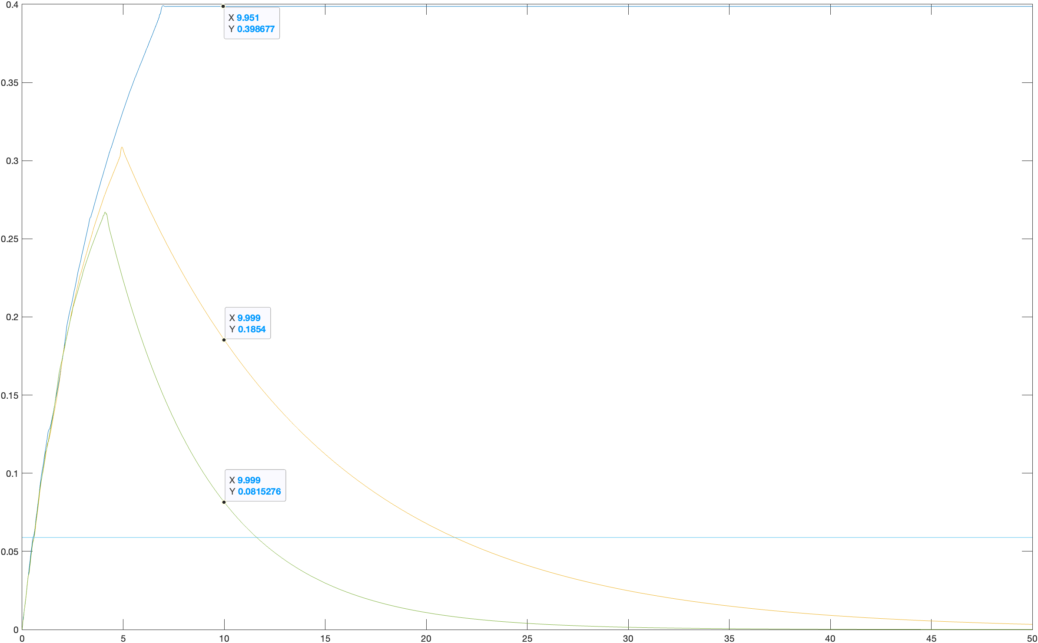

|  |  |  |  |
| --- | --- | --- | --- |
| Integrator gain, Ki | 0 | K1/10 | K1/5 |
| Motor shaft deflection after 10 sec. of disturbance  application | 0.3986 | 0.1854 | 0.0815 |

### Frequency response

The frequency response of a nonlinear system is a function of input command amplitude. This can be evaluated by taking the ratio of the amplitude of fundamental harmonic of system output to the input sinusoidal command amplitude and the phase lag of fundamental harmonic of system output w.r.t the input sinusoidal command. A MATLAB program is developed to carry out the above task. The first part is to generate a sinusoidal sweep command of the specified amplitude and frequency range and the second part is to extract the fundamental harmonic amplitude ratio and phase lag. The MATLAB subroutines

sweep.m and dtfa.m are developed to implement these tasks. The programs are given in the appendix. The simulink model for finding the nonlinear system frequency response is shown in Fig 2. The external disturbance is assumed as zero. The output of ‘sweep.m’ is available in MATLAB workspace as vectors ‘T’ (time) and ‘R’ ( command) with a sampling interval of 0.001 sec. SIMULINK also use the same sampling interval for numerical simulation. The stop time for SIMULINK should be kept as max(T). The simulink simulation results should be available as vectors ‘t’ (time) and ‘y’ (output) in the MATLAB workspace . These outputs will be processed by the ‘dtfa.m’ to evaluate the nonlinear system frequency response.

The frequency response is to be evaluated for the following set of command parameters:

***Command amplitude*** (A in sweep.m): 2%, 5%, 10% and 100% of 4*398/180

***Frequency vector*** (freq in sweep.m) : [0.1 to 0.9 Hz in steps of 0.1 Hz, 1 Hz to 9 Hz in steps of 1 Hz and 10 Hz to 100 Hz in steps of 5 Hz)

***Number of cycles*** ( Nc in sweep.m) : one cycle for 0.1 Hz to 0.9 Hz, 3 cycles for 1 Hz to 9 Hz and 5 cycles for 10 Hz to 100 Hz.

2% command amplitude:



5% command amplitude:

10% command amplitude:

100% command amplitude:

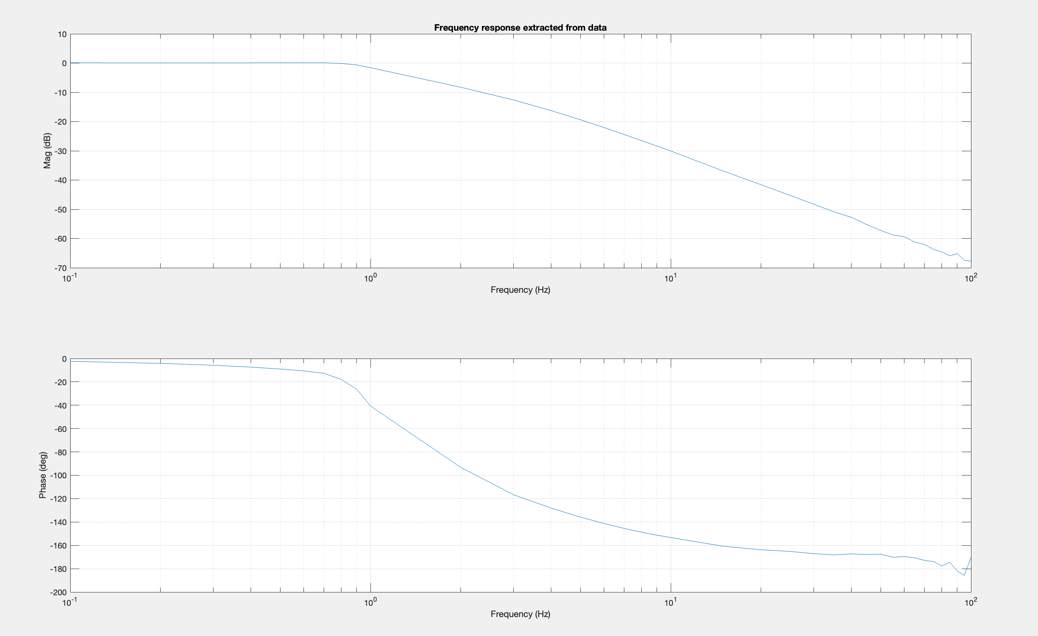

The following results are to be obtained from the frequency response.

|  |  |  |  |  |
| --- | --- | --- | --- | --- |
| Command amplitude | 2% | 5% | 10% | 100% |
| -3dB  Bandwidth (Hz) | 0.27 | 3.39 | 4.25 | 1.16 |
| - 90deg  Bandwidth (Hz) | 2.33 | 4.04 | 4.31 | 1.92 |

# Speed torque characteristics and load locus

The speed torque characteristics of the motor can be plotted along with the simulation data for different command profiles. Typical command profiles are 100% sinusoidal command and 10% sinusoidal command with 5 Hz frequency. The former will force the motor to operate along its speed-torque saturation boundary where as the latter will be within the motor capacity limits. The speed torque characteristics of the motor can be plotted using the following MATLAB commands.

plot([Vs/KB 0],[0 KT*Vs/Ra]) hold on

plot([-Vs/KB 0],[0 –KT*Vs/Ra]) plot(Speed_Torque(:,1),Speed_Torque(:,2)) grid on

Plot for 100% of command amplitude:

For 10% command amplitude:

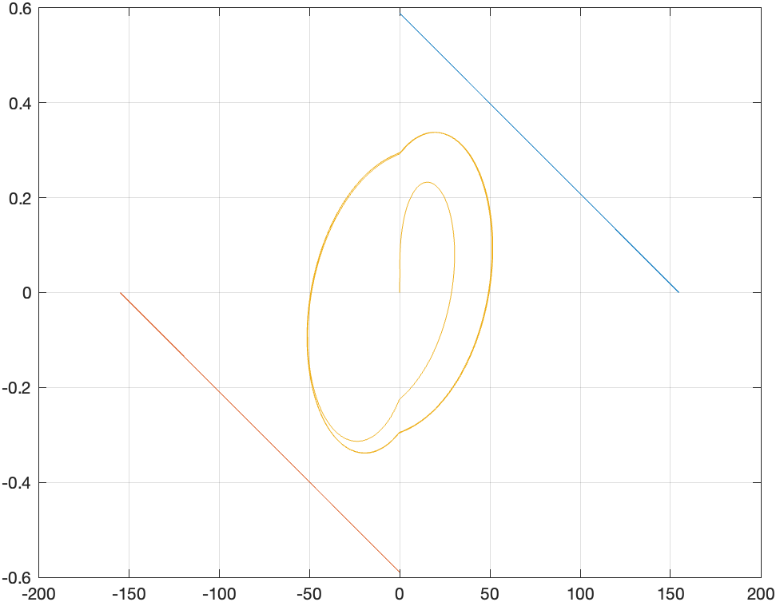

# Conclusions:

* We can’t use linearization and control system toolbox here. Nonlinear factors like friction, limits of certain variables were considered. Step response and disturbance response were more direct since MATLAB supported direct commands. However, for frequency response we needed to generate the sine wave and the bode plot logic by coding rather than by direct commands. The outputs for different command amplitudes were studied. Finally we obtained the expected speed torque characteristics and load locus which are crucial for studying the mechanical system.
* Rise time is maximum for 5% command amplitude and minimum for 10% command amplitude.
* Here the slope of the curves plotted were large which may induce some error while observing the values.
* Disturbance response is maximum for ki=0 and maximum of ki=k1/5;
* -3dB BW is minimum for 2% command amplitude and minimum for 10% command amplitude.
* -90 degrees BW is minimum for 100% command amplitude and maximum for 10% command amplitude.
* The speed torque characteristics reveal that for 100% command amplitude the motor is operating near the edge of saturation and some part of the load locus goes beyond the boundary. For 10% command amplitude the motor is operated within the specified saturation limits.

**Appendix**

**MATLAB Parameter File**

## % par2.m Compensator design for Electromechanical system

% system parameter values KT=0.181;KB=0.181;Jm=1.1694e-

4;JL=12.753;N=1/398;%N=Nm/NL, the inverse gear ratio Bm=2.943e-4;BL=58.86;Ra=8.6;Kp=0.36;KTG=0.1;

% Closed loop specifications wb=5*2*pi; % -3 db Bandwidth = 5 Hz zt=0.6; % Damping factor

% Controller design equations

wn=wb/sqrt((1-2*zt^2)+sqrt(4*zt^4-4*zt^2+2)); J=Jm+N^2*JL;B=Bm+KT*KB/Ra+N^2*BL;K=KT/Ra;B1=Bm+N^2*BL;

K1=wn^2*J/(Kp*K); K2=(2*zt*wn*J-B)/(K*KTG);

Ki=K1/5;Kd=K2*KTG/Kp; % PID controller gains,(K1,Ki,Kd)

% Nonlinear elements

Tfr=0.06; % Coulomb friction w.r.t motor shaft in N-m thm_lmt=4*398*pi/180; % this corresponds to the gimbal deflection limit of 4 deg

Vs=28; % Power supply voltage limit of motor drive

**Matlab Program for sweep command generation**

%sweep_mod.m

% modified by Ameya for adjusting mismatch during zero crossings clc;

close all; clear all; Ts=0.001; tc(1)=0; I=1;

freq1=[0.1:0.1:0.9]; freq2=[1:1:9]; freq3=[10:5:100];

freq=[freq1 freq2 freq3]; A=10;

tlast=0;

for j=1:length(freq) tp=1/freq(j); Nj=tp/Ts;

if freq(j)<1,Nc(j)=1; elseif freq(j)<10

Nc(j)=3;

else Nc(j)=5;

end Ist(j)=I;

for i=I:fix(Nc(j)*Nj)+I

% Tst(j)=(I-1+fix((Nc(j)-4)*Nj))*Ts; %For skipping first cycle Tst(j)=Ist(j)*Ts; % For integrating full cycle

F(j)=freq(j); rc(i)=A*sin(2*pi*freq(j)*(tc(i)-tlast)); tc(i+1)=tc(i)+Ts;

end tlast=tc(i); I=i;

end R=rc(1:i);T=tc(1:i); plot(T,R);

grid on;

save com_par F Tst Nc T R

**MATLAB program for nonlinear system frequency response evaluation**

% dtfa.m program for finding the frequency response from

% experimental/simulation results

%com_par should contain Frequency vector(F),Starting

%time for each frequency(Tst), number of cycles for each

%frequency(Nc),and command vector (R)

%load simout OR Matab workspace should contain the simulation time vector

%'t' and simulation output, 'y' Y=y;T=t;

load com_par; Ts=T(5)-T(4);

for i=1:length(F)

% Tend(i)=Tst(i)+4/F(i); % for skipping first cycle of each frequency of the sweep Tend(i)=Tst(i)+Nc(i)/F(i); % for using full cycle integration

Ns(i)=fix(Tst(i)/Ts); Ne(i)=fix(Tend(i)/Ts);Ne(i)=min(Ne(i),max(length(T))-1); A=max(R(Ns(i):Ne(i)));P=0;Q=0;

ph(i)=2*pi*F(i)*Ns(i)*Ts; for k=Ns(i):Ne(i)

q(k)=A*cos(2*pi*F(i)*k*Ts-ph(i));

r(k)=A*sin(2*pi*F(i)*k*Ts-ph(i)); P=P+r(k)*Y(k)*Ts/A;Q=Q+q(k)*Y(k)*Ts/A;end P=P/Nc(i);Q=Q/Nc(i); % assuming full cycles for integration

%P=P/4;Q=Q/4; % assuming 4 cycles for integration gain(i)=10*log10((P^2+Q^2)*(2*F(i)/A)^2); phase(i)=180/pi*atan2(Q,P);

if phase(i)>0,phase(i)=phase(i)-360;end,end subplot(2,1,1)

semilogx(F,gain);xlabel('Frequency (Hz)');ylabel('Mag (dB)'); title('Frequency response extracted from data')

grid on subplot(2,1,2)

semilogx(F,phase);xlabel('Frequency (Hz)');ylabel('Phase (deg)') grid on